Bahria University,

Karachi Campus



COURSE: CSC-113 COMPUTER PROGRAMMING

TERM: FALL 2019, CLASS: BSE- 1 (A)

Submitted By:

M Muaz Shahzad 02-131202-081

(Name) (Reg. No.)

Submitted To:

Engr. Adnan ur rehman/ Engr. Ramsha Mashood

Signed Remarks: Score:

INDEX

|  |  |  |  |  |
| --- | --- | --- | --- | --- |
| SNO | DATE | LAB NO | LAB OBJECTIVE | SIGN |
| 01 | 27-10-2020 | 06 | CONDITIONAL STATEMENT |  |
|  |  |  |  |  |
|  |  |  |  |  |
|  |  |  |  |  |
|  |  |  |  |  |
|  |  |  |  |  |
|  |  |  |  |  |
|  |  |  |  |  |
|  |  |  |  |  |
|  |  |  |  |  |
|  |  |  |  |  |
|  |  |  |  |  |
|  |  |  |  |  |
|  |  |  |  |  |
| SNO | DATE | LAB NO | LAB OBJECTIVE | SIGN |
|  |  |  |  |  |
|  |  |  |  |  |
|  |  |  |  |  |
|  |  |  |  |  |
|  |  |  |  |  |
|  |  |  |  |  |
|  |  |  |  |  |
|  |  |  |  |  |
|  |  |  |  |  |
|  |  |  |  |  |
|  |  |  |  |  |
|  |  |  |  |  |
|  |  |  |  |  |
|  |  |  |  |  |
|  |  |  |  |  |

Bahria University,

Karachi Campus



LAB EXPERIMENT NO.

**06**

LIST OF TASKS

|  |  |
| --- | --- |
| TASK NO | OBJECTIVE |
| **01** | Create a simple program to check whether the no is Even or Odd. |
| **02** | Create a simple Calculator using if else condition in which you will take two numbers input and ask user which operation, he/she wants to perform. |
| **03** | Write a Program using nested ifs in which the user is asked to do the following   1. Confirm if user wants to play the game “Guess the secret number” 2. If false, then print message “Maybe next time”; if true, then ask “Enter your age” 3. If age is less than 5 then print “You are too young to play”, else ask “Enter any number”. 4. If number is equal to the secret number, then print “You have successfully guessed the secret number”. |
| **04** | Create Simple application which will check the vowel using switch case. |
|  |  |
|  |  |
|  |  |
|  |  |
|  |  |
|  |  |
|  |  |
|  |  |
|  |  |

Submitted On:

27-10-2020

(Date: DD/MM/YY)

**Task No. 1: Create a simple program to check whether the no is Even or Odd.**

**Solution:**

namespace Even_or_Odd

{

class Program

{

static void Main(string[] args)

{

int n, R;

Console.Write("Enter A Number : ");

n = Convert.ToInt32(Console.ReadLine());

R = n % 2;

if (R == 0)

{

Console.Write("EVEN");

Console.Read();

}

else

{

if (R != 0)

{

Console.Write("ODD");

Console.Read();

}

} }

}

}

**Output:**

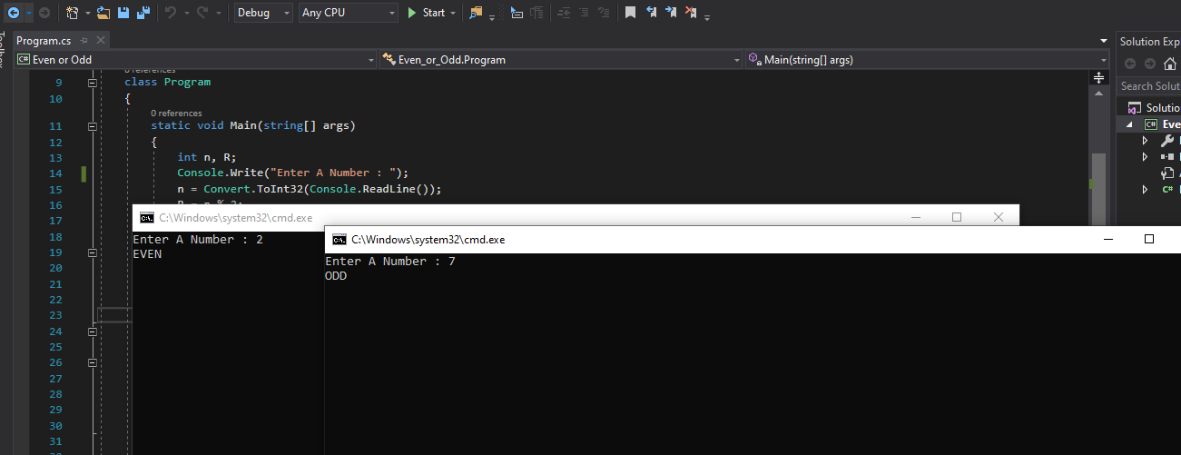

**Task No. 2: Create a simple Calculator using if else condition in which you will take two numbers input and ask user which operation, he/she wants to perform.**

**Solution:** namespace ConsoleApp17

{

class Program

{

static void Main(string[] args)

{

Console.WriteLine("{0,20}", "CALCULATOR" );

Console.WriteLine("----------------------------");

Console.WriteLine("{0,13}","1 Add");

Console.WriteLine("{0,19}","2 Substract");

Console.WriteLine("{0,18}","3 Multiply");

Console.WriteLine("{0,16}","4 Divide");

Console.Write("Choose Number Between(1-4): ");

int d = Convert.ToInt32(Console.ReadLine());

double a, b, c;

if (d == 1)

{

Console.Write("Enter Num: ");

a = Convert.ToDouble(Console.ReadLine());

Console.Write("Enter Num: ");

b = Convert.ToDouble(Console.ReadLine());

c = a + b;

Console.WriteLine("\nSum Result = {0}", c);

}

else if (d == 2)

{

Console.Write("Enter Num: ");

a = Convert.ToDouble(Console.ReadLine());

Console.Write("Enter Num: ");

b = Convert.ToDouble(Console.ReadLine());

c = a - b;

Console.WriteLine("\nSubtraction Result = {0}", c);

}

else if (d == 3)

{

Console.Write("Enter Num: ");

a = Convert.ToDouble(Console.ReadLine());

Console.Write("Enter Num: ");

b = Convert.ToDouble(Console.ReadLine());

c = a * b;

Console.WriteLine("Product Result = {0}", c);

}

else if (d == 4)

{

Console.Write("Enter Num: ");

a = Convert.ToDouble(Console.ReadLine());

Console.Write("Enter Num: ");

b = Convert.ToDouble(Console.ReadLine());

c = a / b;

Console.WriteLine("Division Result = {0}", c);

}

else

{

Console.WriteLine("Invalid Choice");

}

Console.ReadKey();

}

}

}

**Output:**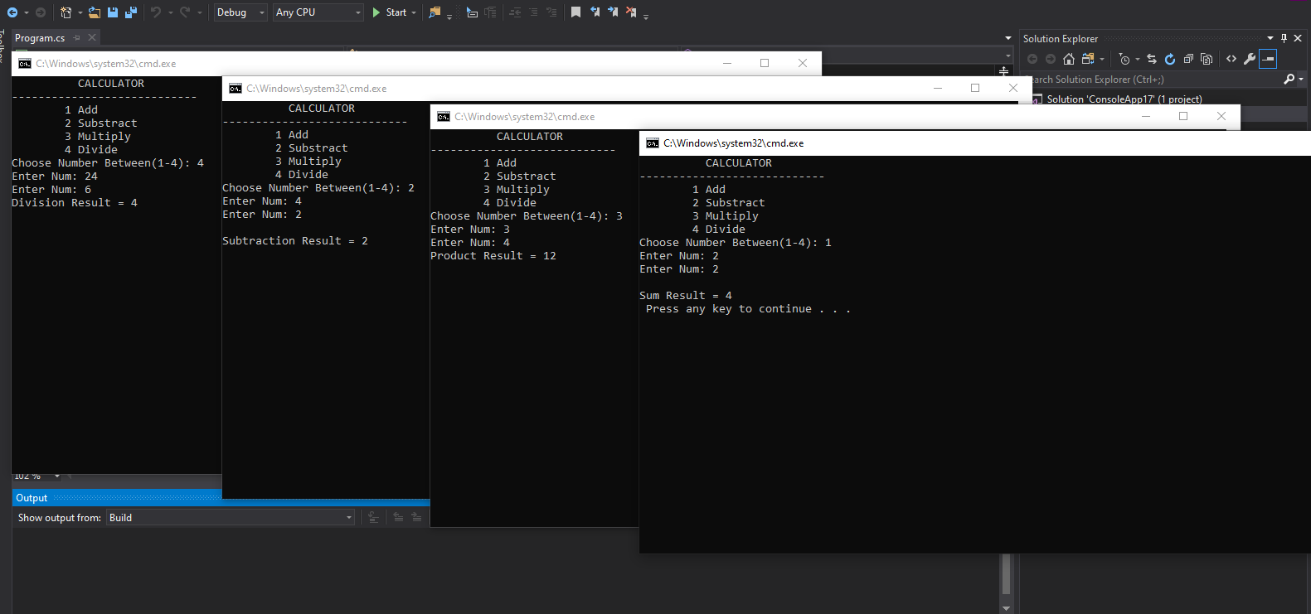

**Task No. 3:** **Write a Program using nested ifs in which the user is asked to do the following**

1. **Confirm if user wants to play the game “Guess the secret number”**
2. **If false, then print message “Maybe next time”; if true, then ask “Enter your age”**
3. **If age is less than 5 then print “You are too young to play”, else ask “Enter any number”.**
4. **If number is equal to the secret number, then print “You have successfully guessed the secret number”.**

**Solution:**namespace Secret_Num

{

class Program

{

static void Main(string[] args)

{

double m = 100, c, r;

int b;

Console.Write("GUESS THE SECRET NUMBER : ");

r = Convert.ToInt32(Console.ReadLine());

if (r == m)

{

Console.Write("ENTER YOUR AGE : ");

b = Convert.ToInt32(Console.ReadLine());

if (b < 5)

{

Console.Write("YOU ARE TOO YOUNG TO PLAY ");

}

else

if (b > 5)

{

Console.Write("ENTER ANY NUMBER : ");

c = Convert.ToDouble(Console.ReadLine());

if (c == m)

{

Console.WriteLine("You have Successfully Guessed The Secret Number");

}

else

if (c != m)

{

Console.WriteLine("You were not Successful Guessed The Secret Number");

}

}

}

else

if (r != m)

{

Console.WriteLine("May Be Next Time ");

}

}

}

}

**Output:**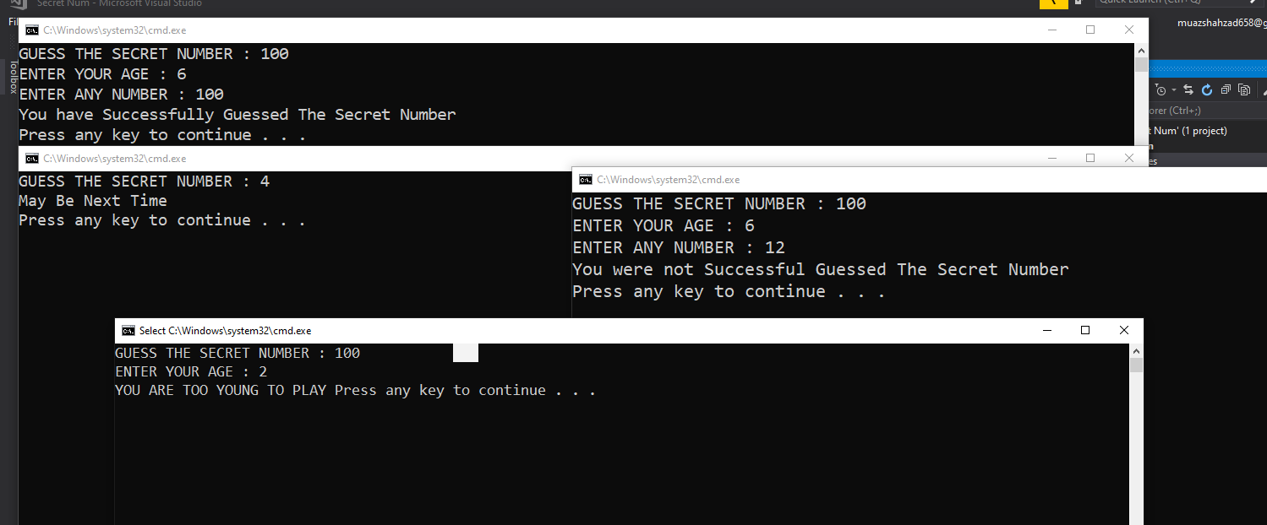

**Task No. 4: Create Simple application which will check the vowel using switch case.**

**Solution:**namespace vowels

{

class Program

{

static void Main(string[] args)

{

Char z;

Console.Write("Write an Alphabet : ");

z = Convert.ToChar(Console.Read());

switch (z)

{

case 'a':

Console.WriteLine("Your Alphabet is vowel");

break;

case 'i':

Console.WriteLine("Your Alphabet is vowel");

break;

case 'o':

Console.WriteLine("Your Alphabet is vowel");

break;

case 'u':

Console.WriteLine("Your Alphabet is vowel");

break;

case 'e':

Console.WriteLine("Your Alphabet is vowel");

break;

default:

Console.WriteLine("INPUT INVALID");

break;

}

}

}

}

**OUTPUT:**